CSC 120 Lab 07

Instructions:   
● Please refer to the lectures posted and the textbook in order to answer these questions.   
● Provide screenshots wherever applicable.   
● For programming questions, please provide a screenshot and a link to Google Colab   
● You may refer to online sources for exploration but do not directly copy paste from these sources.

**Question 1: What is the difference between UDP and TCP protocols? Which layer of the OSI model do these protocols belong to? Provide differences in a table. (10 points)**

|  | **TCP** | **UDP** |
| --- | --- | --- |
| **Reliability** | Reliable | Unreliable |
| **Connection** | Connection-oriented | Connectionless |
| **Orderliness** | Segment sequencing | No sequencing |
| **Control** | Segment transmission and flow control through windowing | No windowing or retransmission |
| **Acknowledgment** | Acknowledge sequencing | No acknowledgment |
| **Data transfer form** | Flow | Datagram |
| **Application** | Where reliability and orderliness is required  www,e-mail,FTP, SSH | Where there is a high load on the server and the loss of some packets is not critical  DNS, DHCP, SNMP, voice and video traffic, games |
| **Speed** | Slower | Faster |

TCP and UDP are transport layer protocols and as such exist at layer 4 of the OSI model.

**Question 2: List the layers in the OSI model and provide one service, application or example provided by each layer. (10 points)**

| **Layers** | **Application/Example** |
| --- | --- |
| Application | Resource sharing, Remote file access, Remote printer access, Directory services, Network Management |
| Presentation | Character code translation, Data conversion, Data compression, data encryption, character set translation |
| Session | Session establishment, maintenance, and termination, Session support - perform security, name recognition, logging, etc. |
| Transport | Message segmentation, Message acknowledgement, Message traffic control, Sessions multiplexing |
| Network | Routing, Subnet traffic control, Frame fragmentation, Logical-physical address mapping, Subnet usage accounting |
| Data Link | Establishes and terminates the logical link between nodes, Frame traffic control, Frame sequencing, Frame acknowledgement, Frame delimiting, Frame error checking, Media access control |
| Physical | Data encoding, Physical medium attachment, Transmission technique - baseband or broadband, Physical medium transmission Bits and Volts |

**Question 3: What is the difference between HTTP and HTTPS? What is encryption and what is its benefit ? (10 points)** HTTPS and HTTP are two protocols by which information is transmitted on the Internet. They are designed to transfer text data between a client and a server, and the main difference between them is the presence and absence of encryption of the transmitted data. HTTPS supports encryption with an enhanced level of secure communication.

Encryption is the process of converting data into code using an algorithm to prevent unauthorized access. In other words, with this we can protect the data by making it impossible to decode it without a password.

Benefits of encryption:

1. Encryption ensures data integrity

If anyone makes any changes to the Encrypted Data, the recipient will easily detect any fraud using hashing, such as an MD5 checksum.

2. Ensuring security at all times.

3. Advantage in data protection on different devices

The encryption and decryption software can be written for any platform, which means the encrypted data is platform independent and can be used across different devices.

4. Encryption ensures confidentiality

**Question 4: Write a brief definition for ports and sockets. What is the port number for email?(10 points)**

A port is a logical construct assigned to network processes so that they can be identified within the system. A socket is a combination of port and IP address. An incoming packet has a port number which is used to identify the process that needs to consume the packet.

Modern email servers use port 587 for the secure submission of email for delivery.   
 **Question 5: What are the risks when connecting to a public wifi network such as a coffee shop, airport, hotel wifi network. What happens if you connect to a website using http vs https over such a network (10 points)**When connected to an open Wi-Fi network in a subway, hotel or airport, user data can be intercepted. The risk of such a connection is high, so it is better not to use Wi-Fi networks that do not have a password. It is easy to connect to such networks and it is also easy to intercept the data of any user. Attackers with basic hacking skills can easily intercept traffic, including user passwords from Internet banking, email, etc. If you browse HTTPS sites, the owner of the WiFi hotspot will only be able to see the URLs of the sites you open, but not the content you browse and download. If you visit sites with HTTP, then the situation will be very different. Since there is no encryption, the WiFi owner can use a packet sniffer and recompile information from the data packets. He will be able to see what web pages you have opened and what content you have viewed.

**Question 6: In this section, we will find the IP address, MAC address of our machines. For this section, we will open the command prompt or terminal on our laptops/PCs. (10 point)**

**Step 0:** Open command prompt on your machine. For Linux, Mac users, this is called the terminal. For Windows, it is called the command prompt.

**Step 1:** For Linux, Mac, run the command ifconfig in the terminal. For Windows, run the command ipconfig in the command prompt.

**Step 2:** Find the Wi-Fi adapter. For Windows, this should be labeled as Wireless LAN adapter Wi-Fi. For Mac, this will be labeled as en1.

**Step 3:** What is the IPv4 address of the Wi-Fi adapter you found above?

Note: Never provide your MAC address or default gateway to strangers. Hackers use this information to gain access to your computer and run malicious scripts that may delete or steal your data.

inet 192.168.86.32

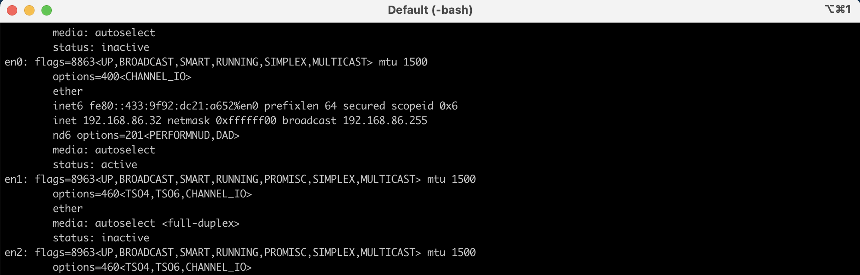

**7. Question 7: In this section, we run a ping command to an existing server. For this section, we will open the command prompt or terminal on our laptops/PCs.(10 points)**

**Step 0:** Open command prompt on your machine. For Linux, Mac users, this is called the terminal. For Windows, it is called the command prompt.

**Step 1:** For Linux, Mac and Windows, run the command ping www.google.com in the terminal.

Note: You can exit the command by pressing Ctrl+C on your keyboard

**Step 2:** Write 2-3 lines about the ping command and what it does.

64 bytes from 142.250.31.104: icmp_seq=0 ttl=103 time=13.909 ms

64 bytes from 142.250.31.104: icmp_seq=1 ttl=103 time=14.352 ms

Using the ping command, we send a packet of a certain size (56 bytes) to the host specified in the command (www.google.com). After a certain time, we receive an answer - the packet is returned. Based on the received packet, you can judge the compatibility of the settings, identify problems with the hardware, as well as evaluate the stability of the computer's connection to network resources and the TCP / IP network as a whole.

**Step 3:** Paste a screenshot of the output.

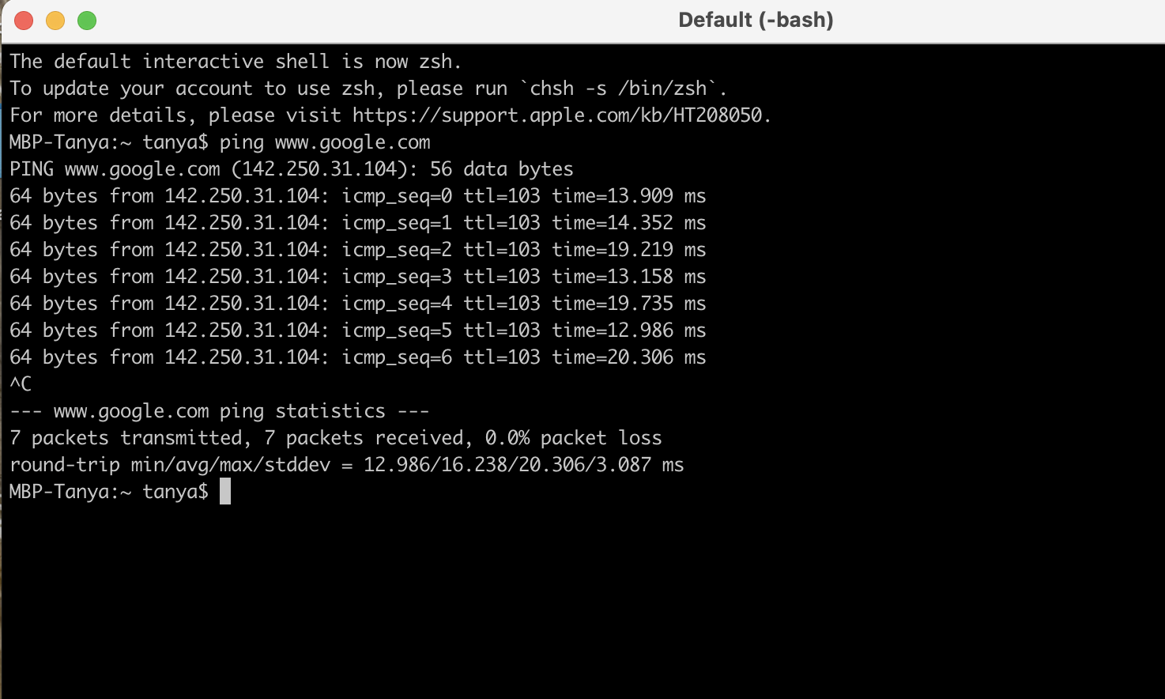

**8. Question 8: Connect to your router. (10 points)**

We will find out more information about the router in your home. This router has an IP address which it uses to connect to devices. The objective of this question is to find the address of your router and make a note of the settings you can change from this interface.

1.Find your router IP address. Use PCMag’s guide to find out how to access your gateway. Note: You will need to login. Generally the default login and password for your router will be found on the internet. You can change this if you want to secure your router but make sure you remember the new password   
2. Questions:

* + What is the frequency of your network?

5 GHz

* + How many bands or channels are available for that frequency?

2 WiFi channels

* + What is the bandwidth of the connection?

1000

* + Can you change your Wi-Fi password from this interface?

Yes

* + Can you change your email password from this interface?

No

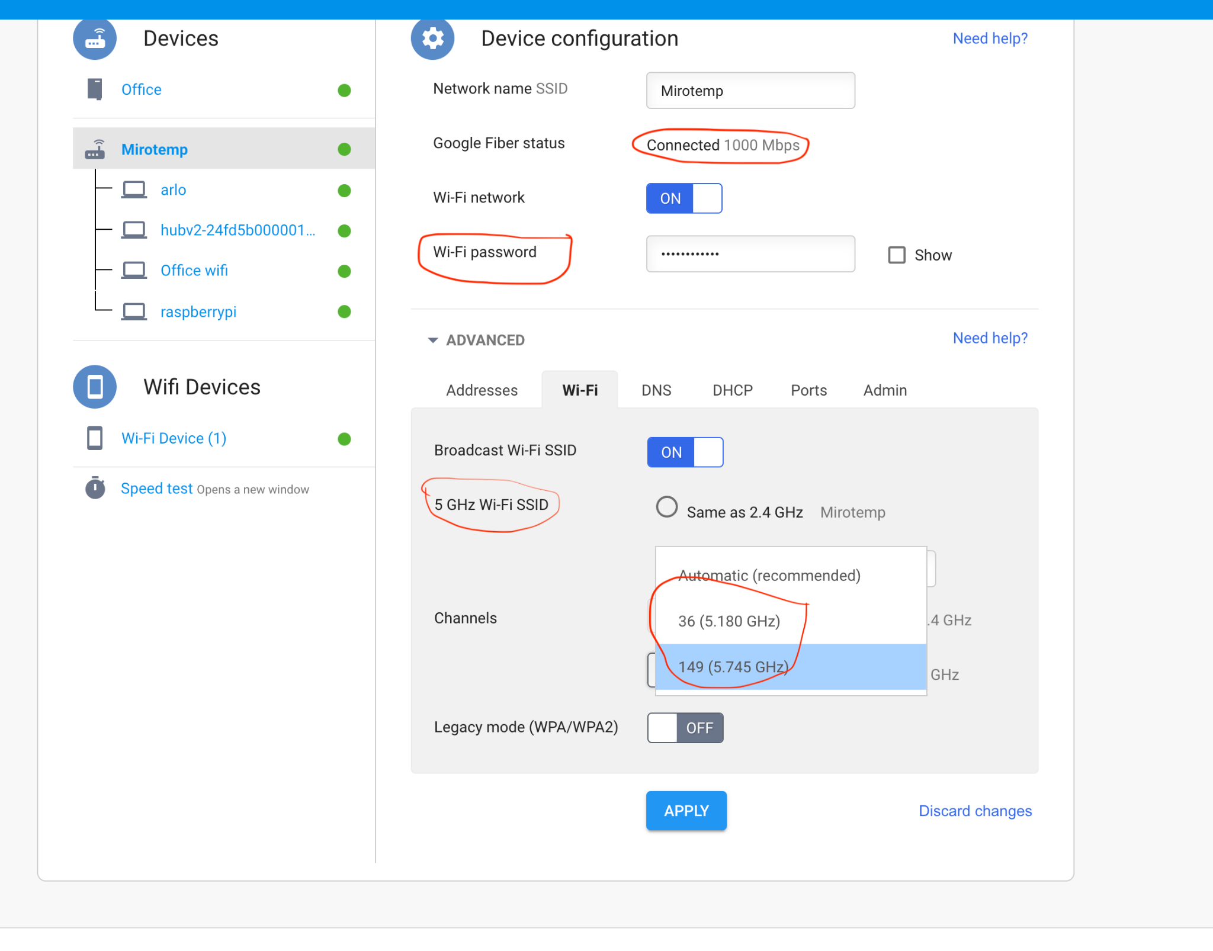

3. General tips:  
The login for default gateway is generally username: admin, password: password. Search the internet for default login instructions.

**9. Question 9: Python program to make a simple GET request. (20 points)**

Definitions: An HTTP request is made by a client, to a named host, which is located on a server. The aim of the request is to access a resource on the server. An HTTP response is made by a server to a client. The aim of the response is to provide the client with the resource it requested, or to inform the client that the action it requested has been carried out, or to inform the client that an error occurred in processing its request. (Defn. from IBM docs)

Run the following code and answer the questions.

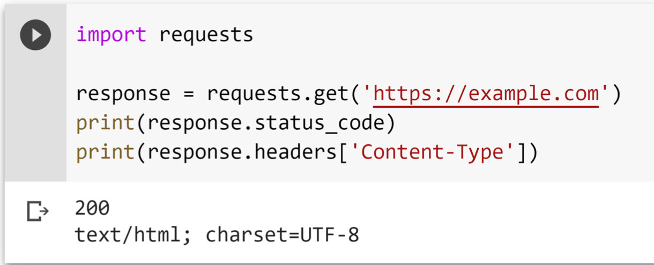

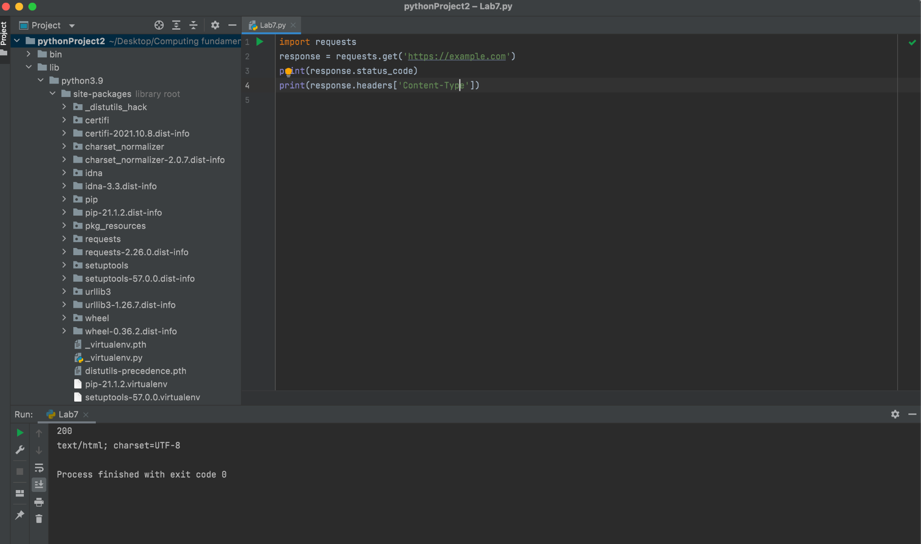

1. What is the meaning of status code 200?

200 ( OK) Standard response for successful HTTP requests. The actual response will depend on the request method used.

1. What is the meaning of status code 404?  
   404 (Not Found The requested resource could not be found but may be available in the future.
2. Write a condition that prints “SUCCESS” if a status code is 200. If not, print “Error”. Paste the output screenshot. Use if...else..

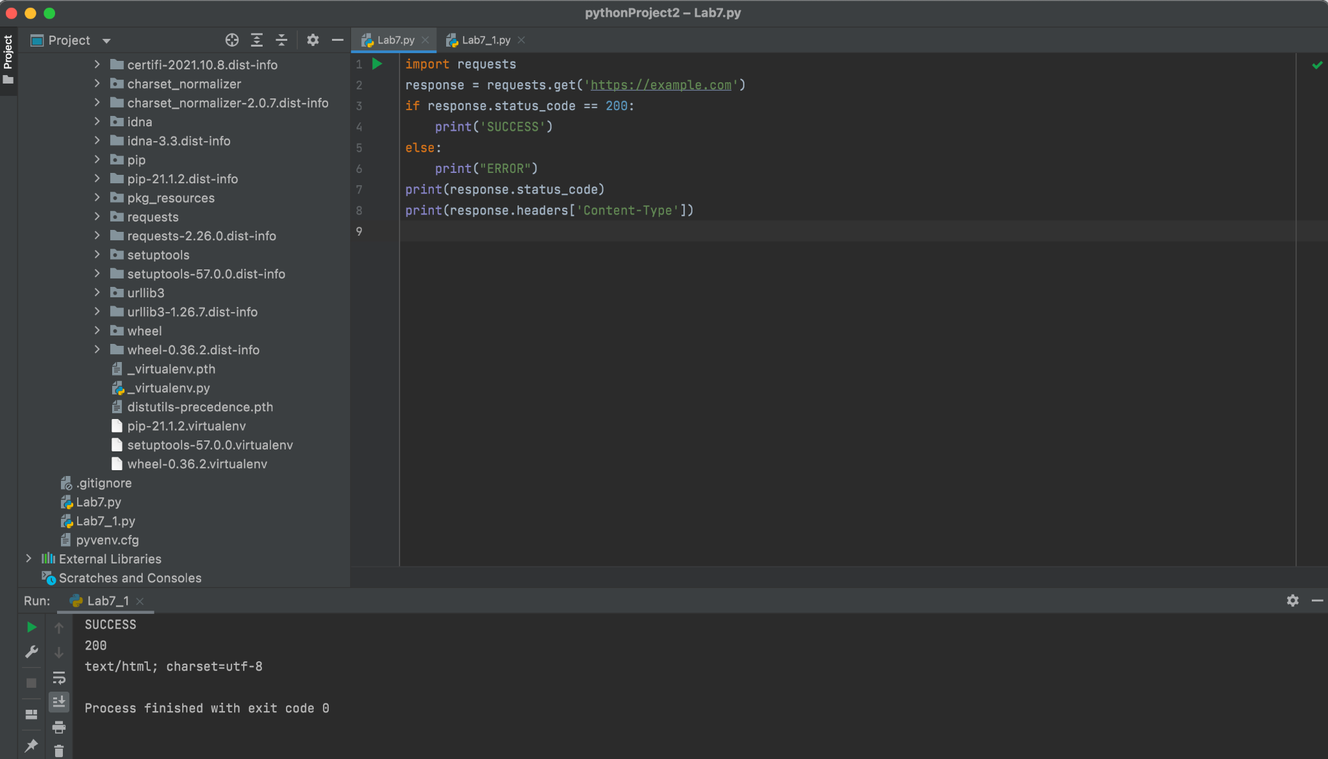

<https://colab.research.google.com/drive/1Ltxah_IKQ_BYDVyDJNdfQ0rx0ZtgImIE?usp=sharing>

1. Replace the URL https://example.com with a website of your choice. Run the code again with the updated website and print out status code and headers. Website Options: <http://www.nytimes.com>

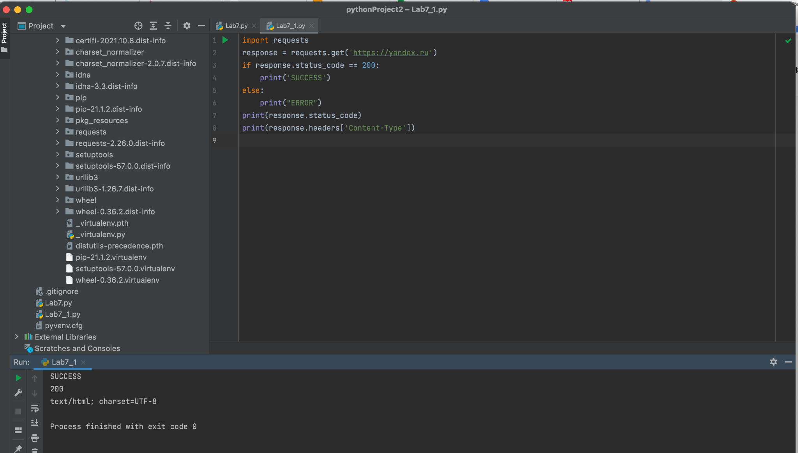

<https://colab.research.google.com/drive/1B1uJppIWifXY0UvvuKFM-uyLoj_06mju?usp=sharing>